**Tableau Homework - Citi Bike Analytics**

**Background:** I am choosing the Citi Bike data between 2019 and 2020 in Jersey City.

<https://www.citibikenyc.com/system-data>

After downloading the data from the above website, I also outer joined these csv files into one data source on Tableau.

• How many trips have been recorded total during the chosen period?

2019: 404,947 Trips

2020: 336,802 Trips

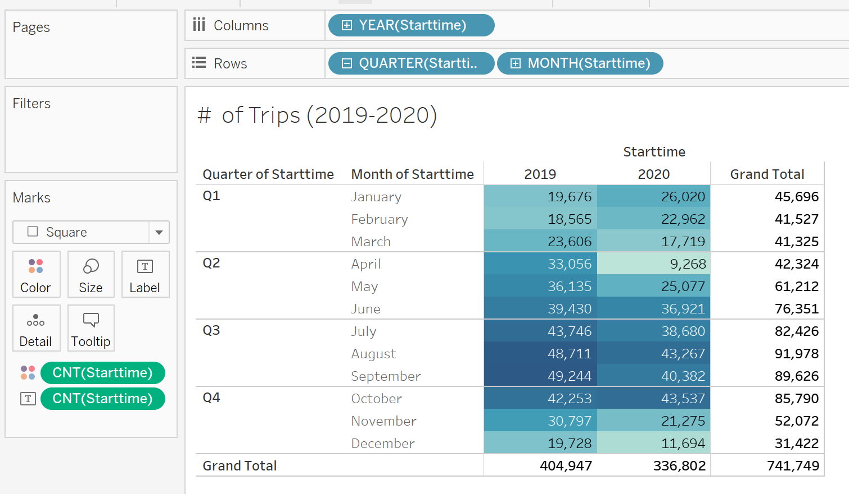

• By what percentage has total ridership grown?

Below is the ridership trend over the 2 year span (2019-2020):

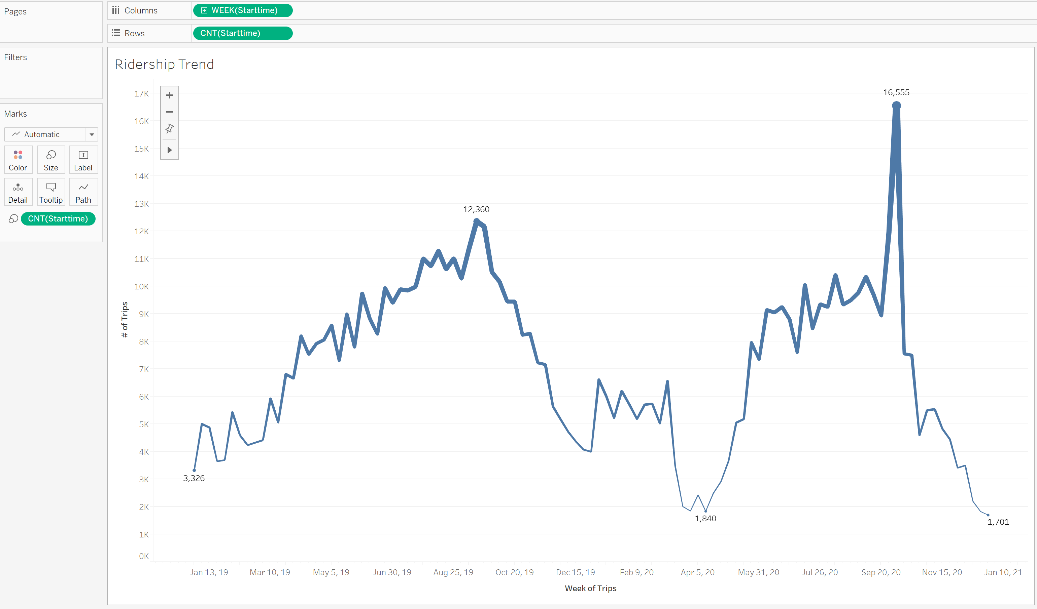

• How has the proportion of short-term customers and annual subscribers changed?

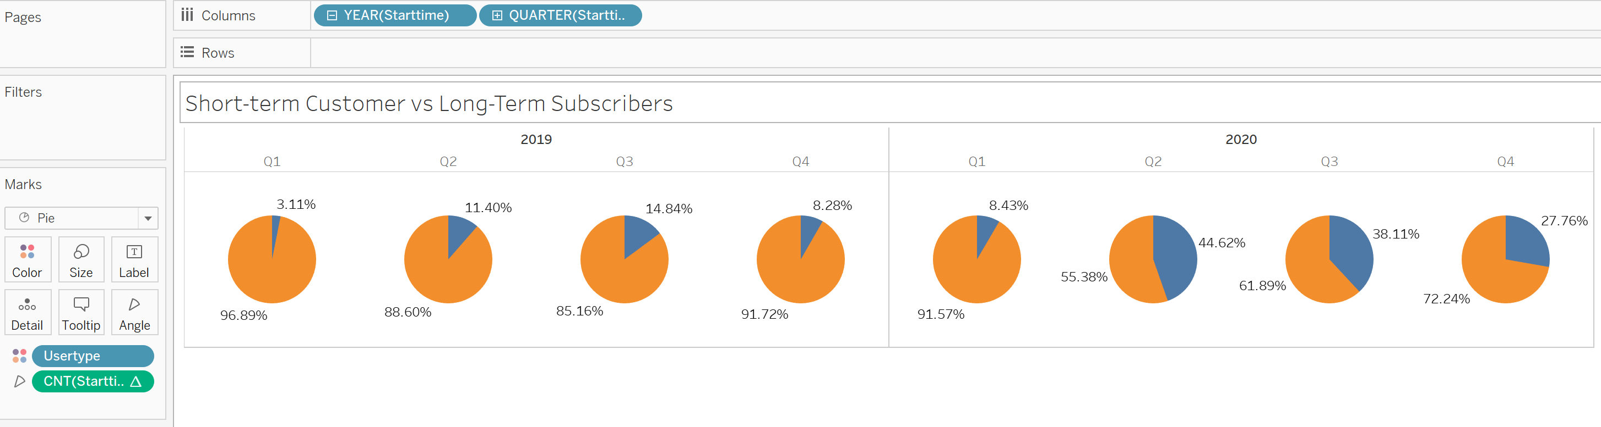

• What are the peak hours in which bikes are used during summer months?

Summer Months: June, July and August

Peak Hour: 6:00pm.

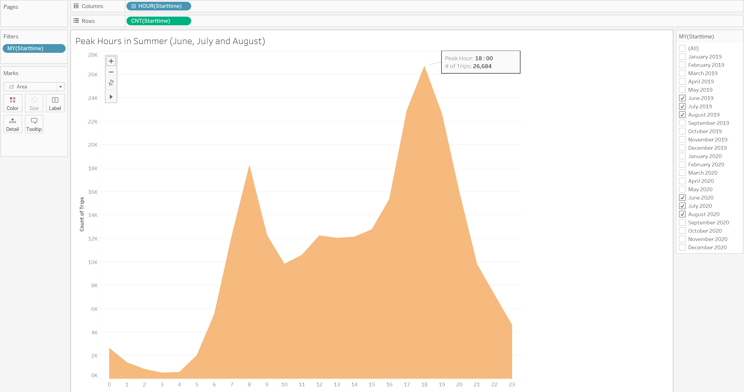

• What are the peak hours in which bikes are used during winter months?

Winter Months: November, December, January and February

Peak Hour: 8:00am

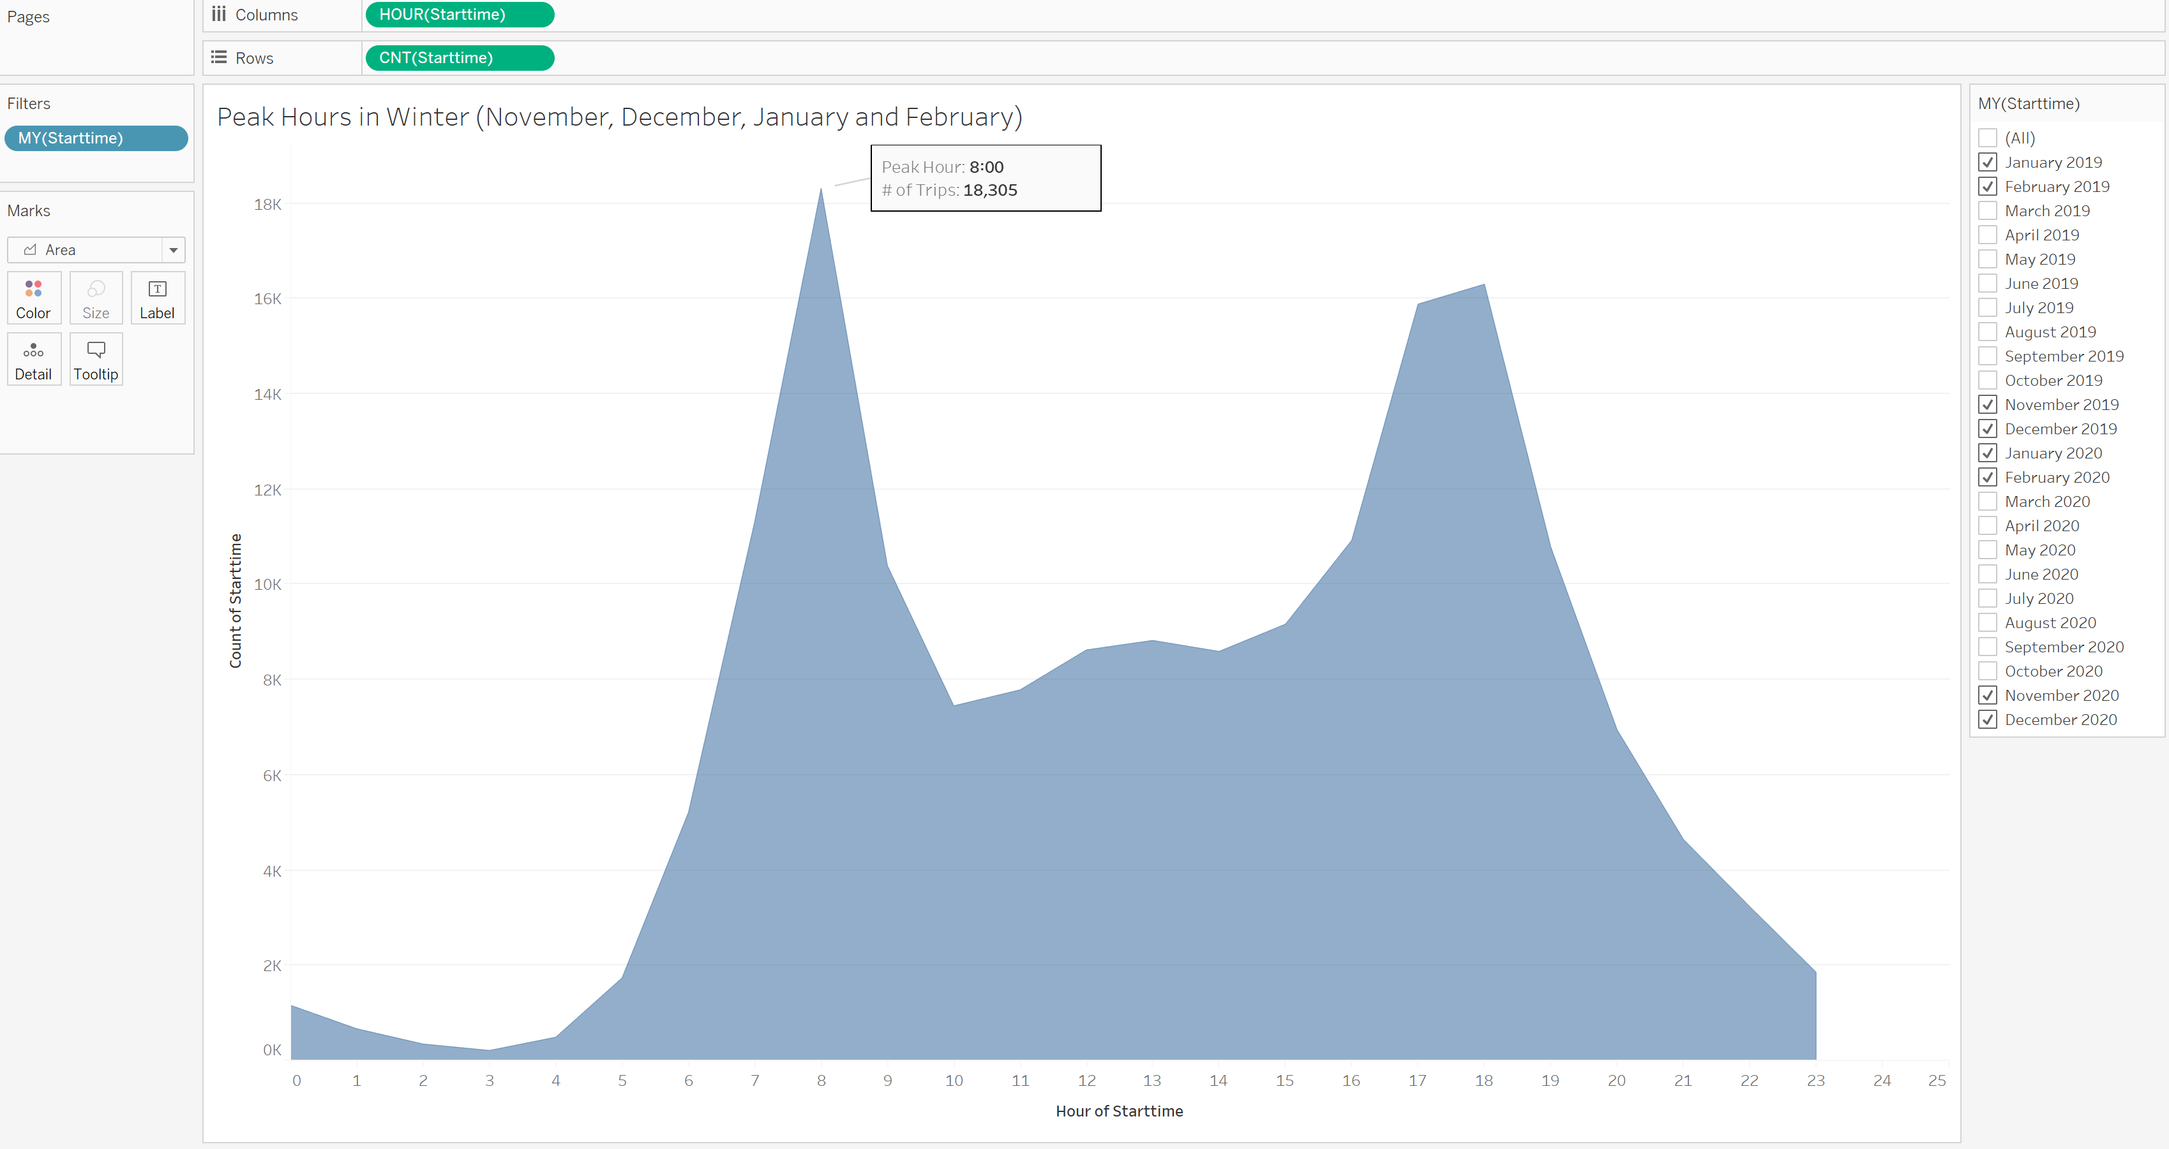

• Today, what are the top 10 stations in the city for starting a journey? (Based on data, why do you hypothesize these are the top locations?)

Top 10 Stations for starting a journey are: 3186, 3203, 3195, 3199, 3639, 3202, 3276, 3192, 3792, 3185.

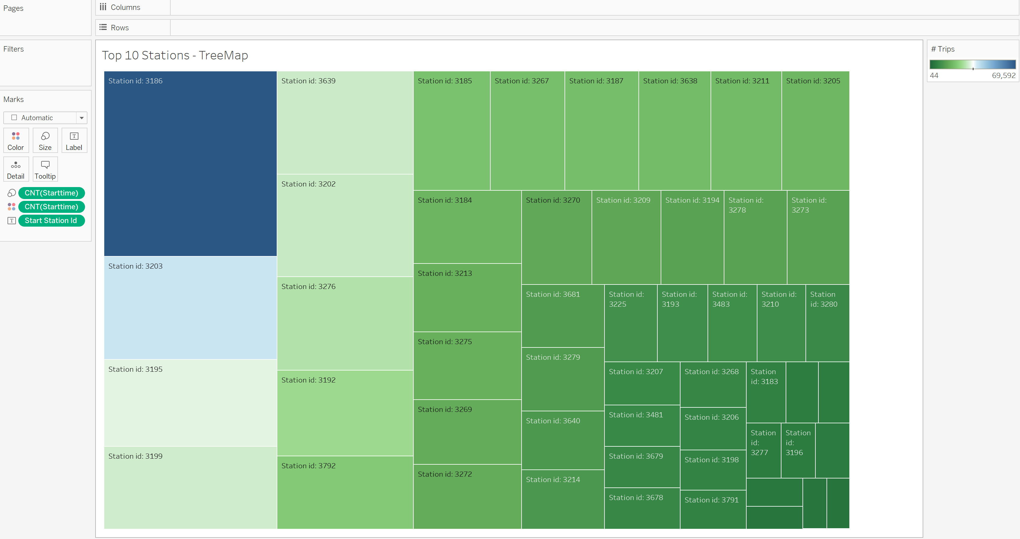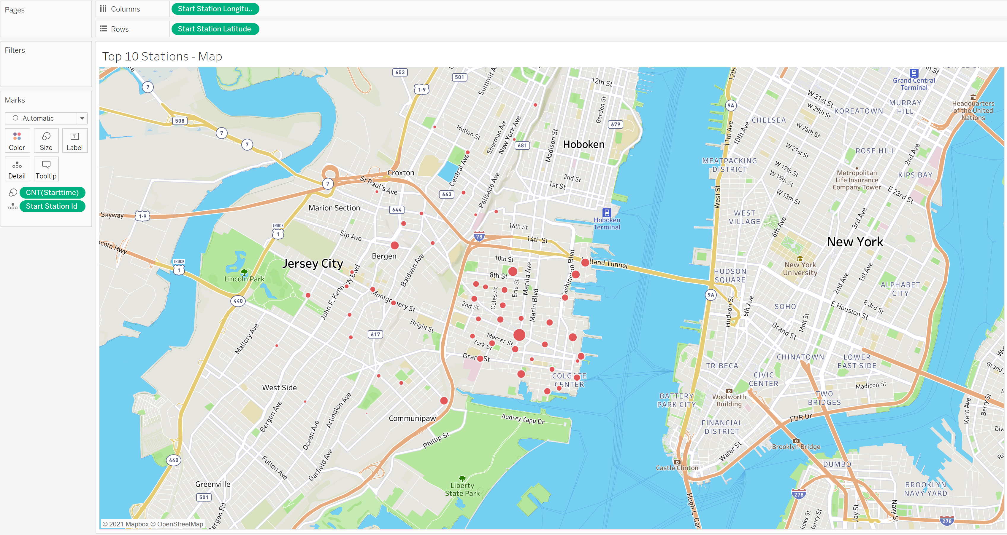

• Today, what are the top 10 stations in the city for ending a journey? (Based on data, why?)

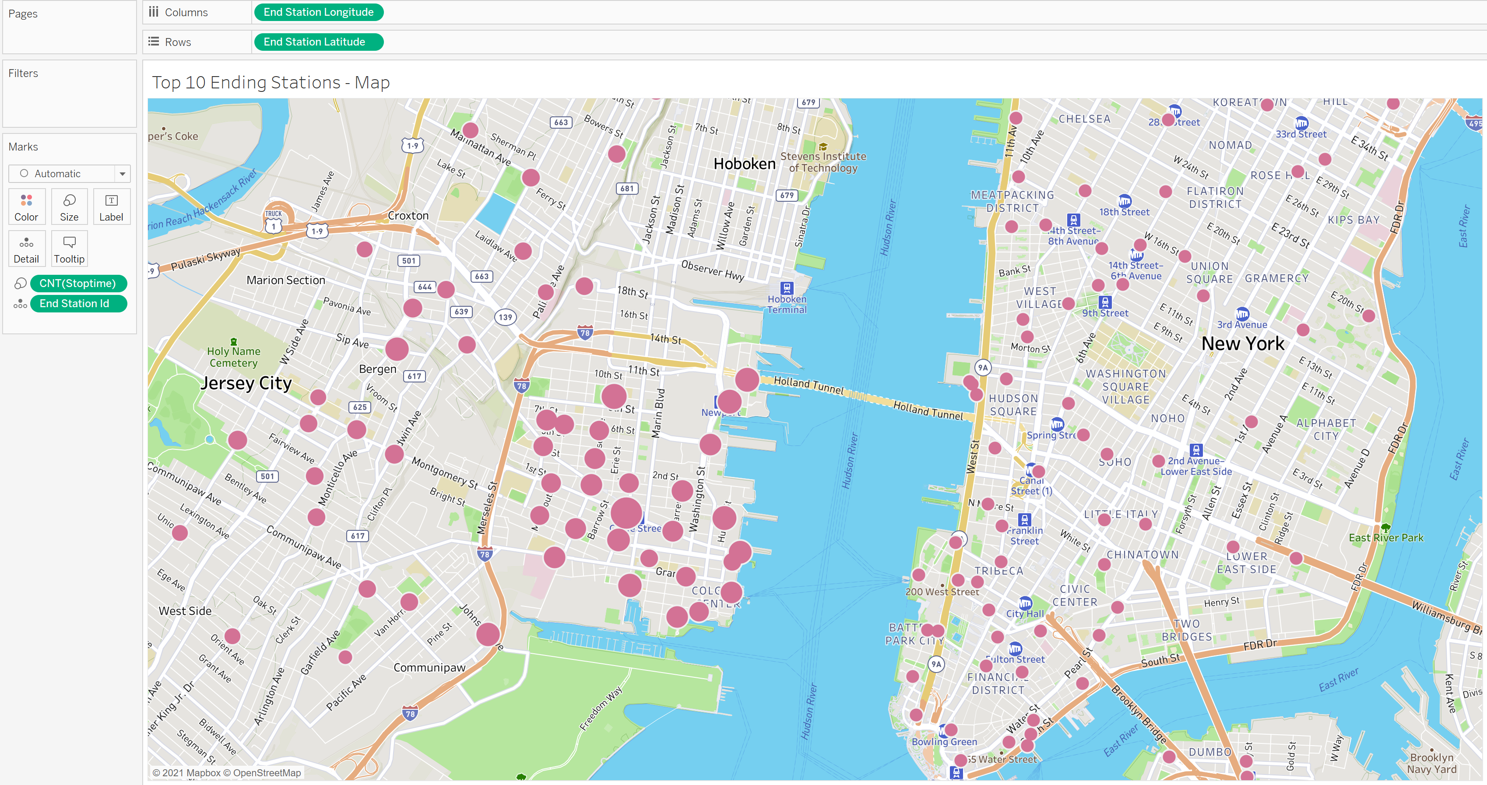

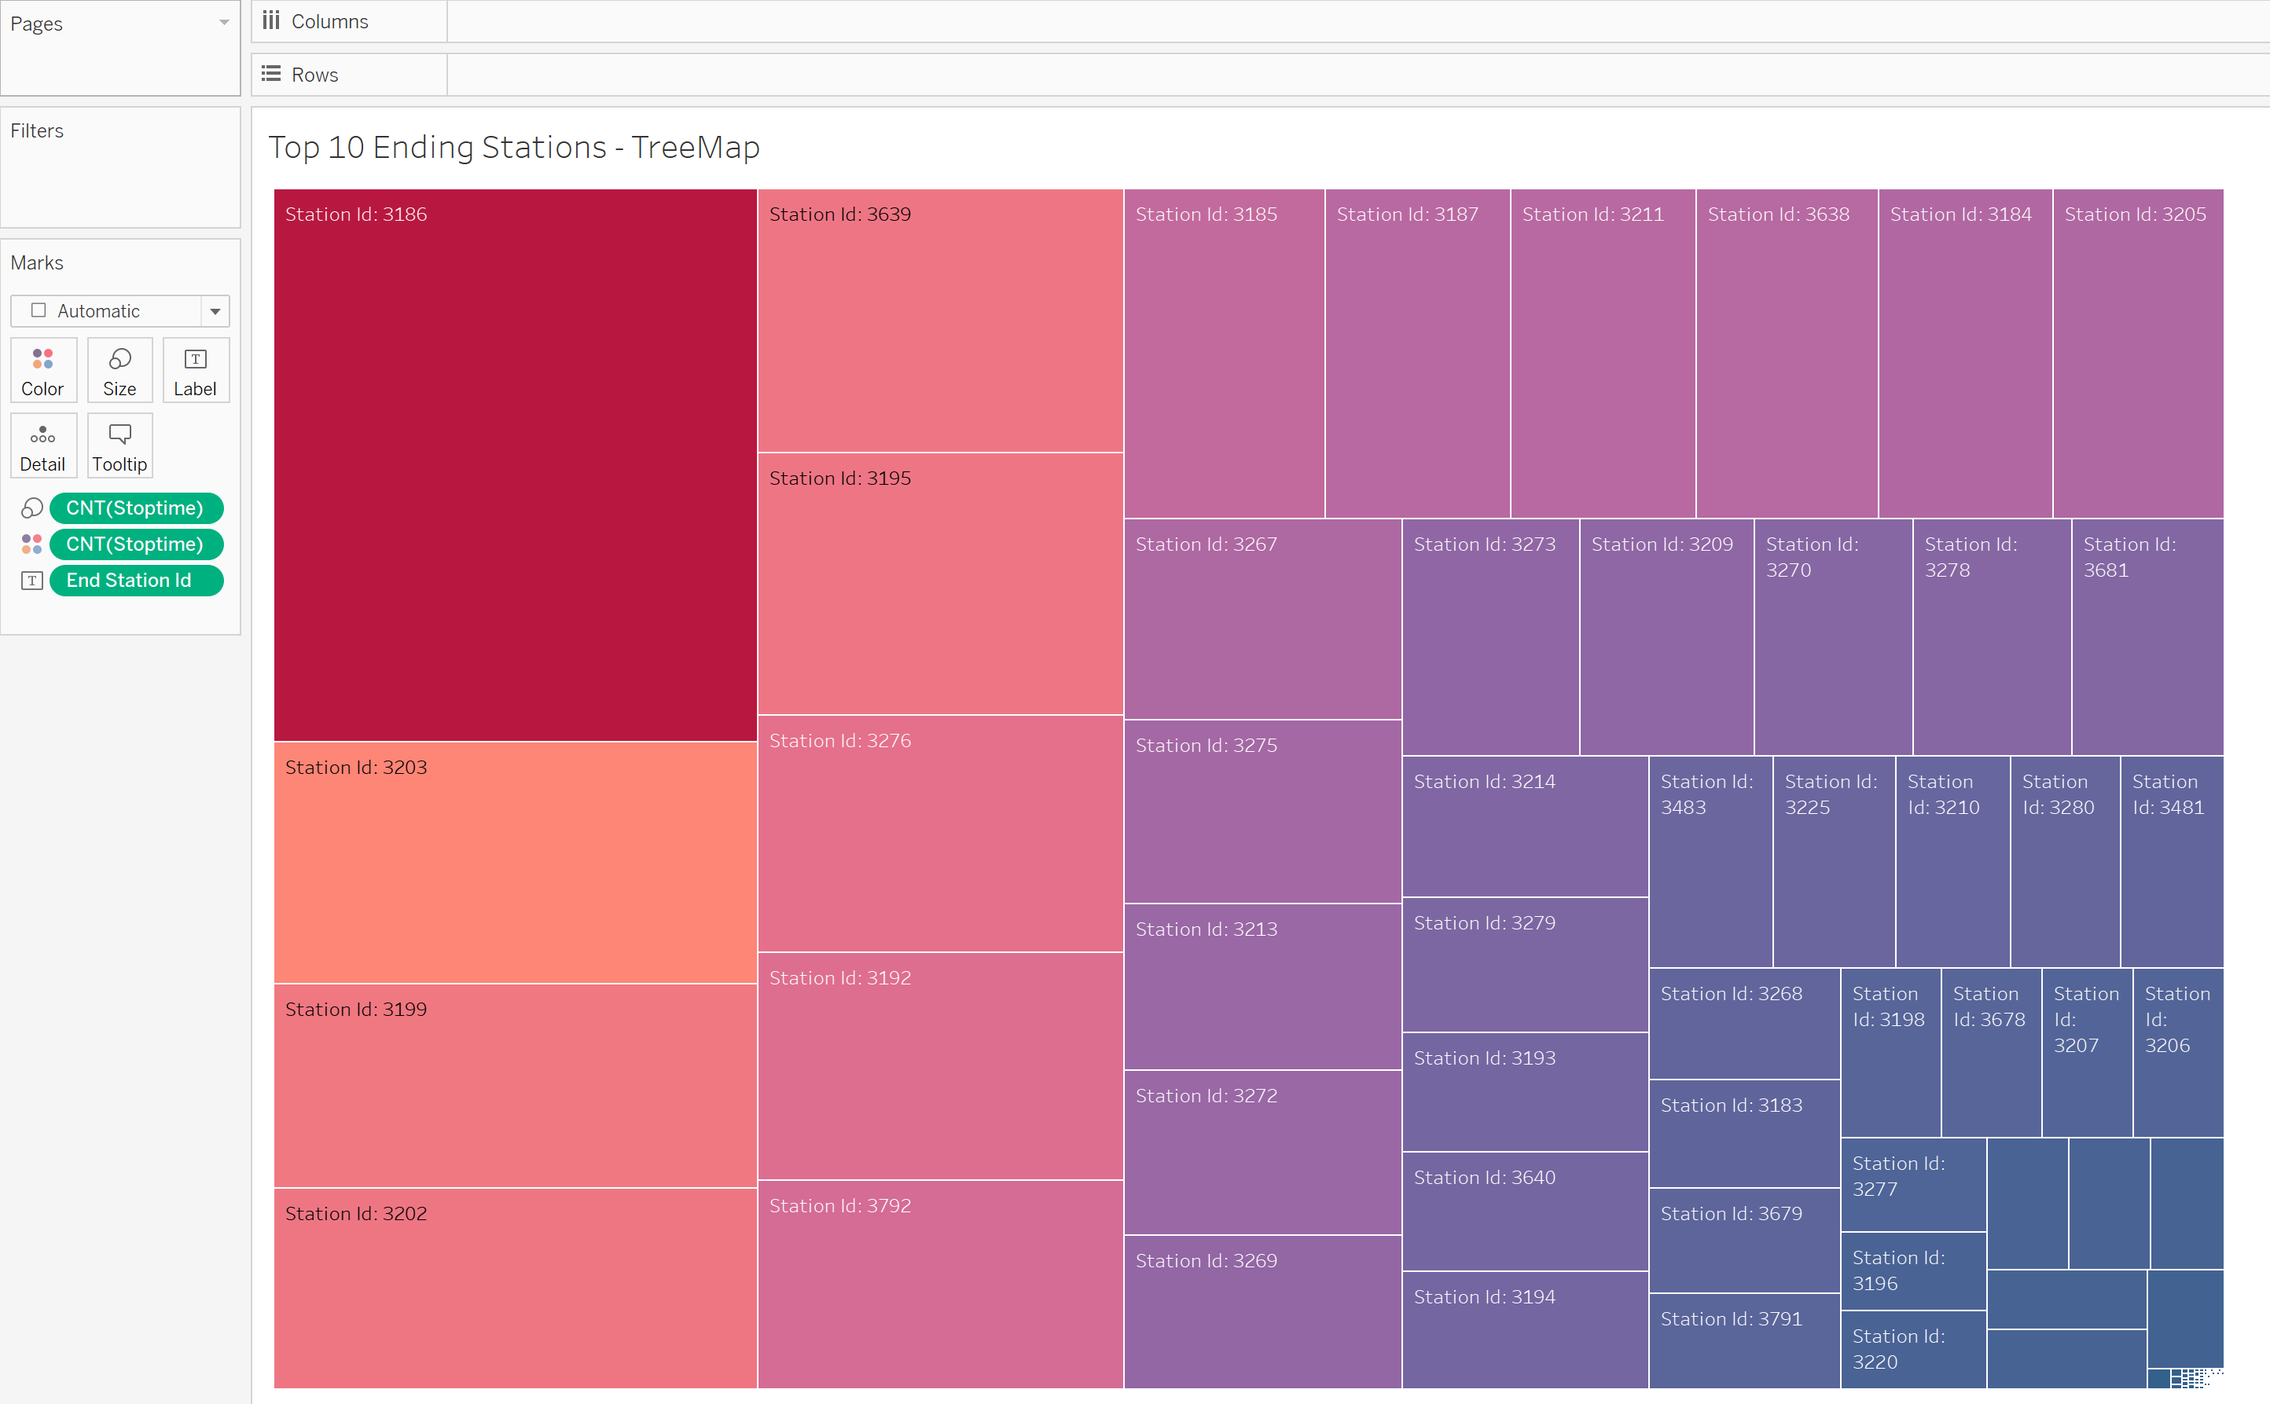

• Today, what are the bottom 10 stations in the city for starting a journey? (Based on data, why?)

Similar idea as above.

• Today, what are the bottom 10 stations in the city for ending a journey (Based on data, why?)

Similar idea as above.

• Today, what is the gender breakdown of active participants (Male v. Female)?

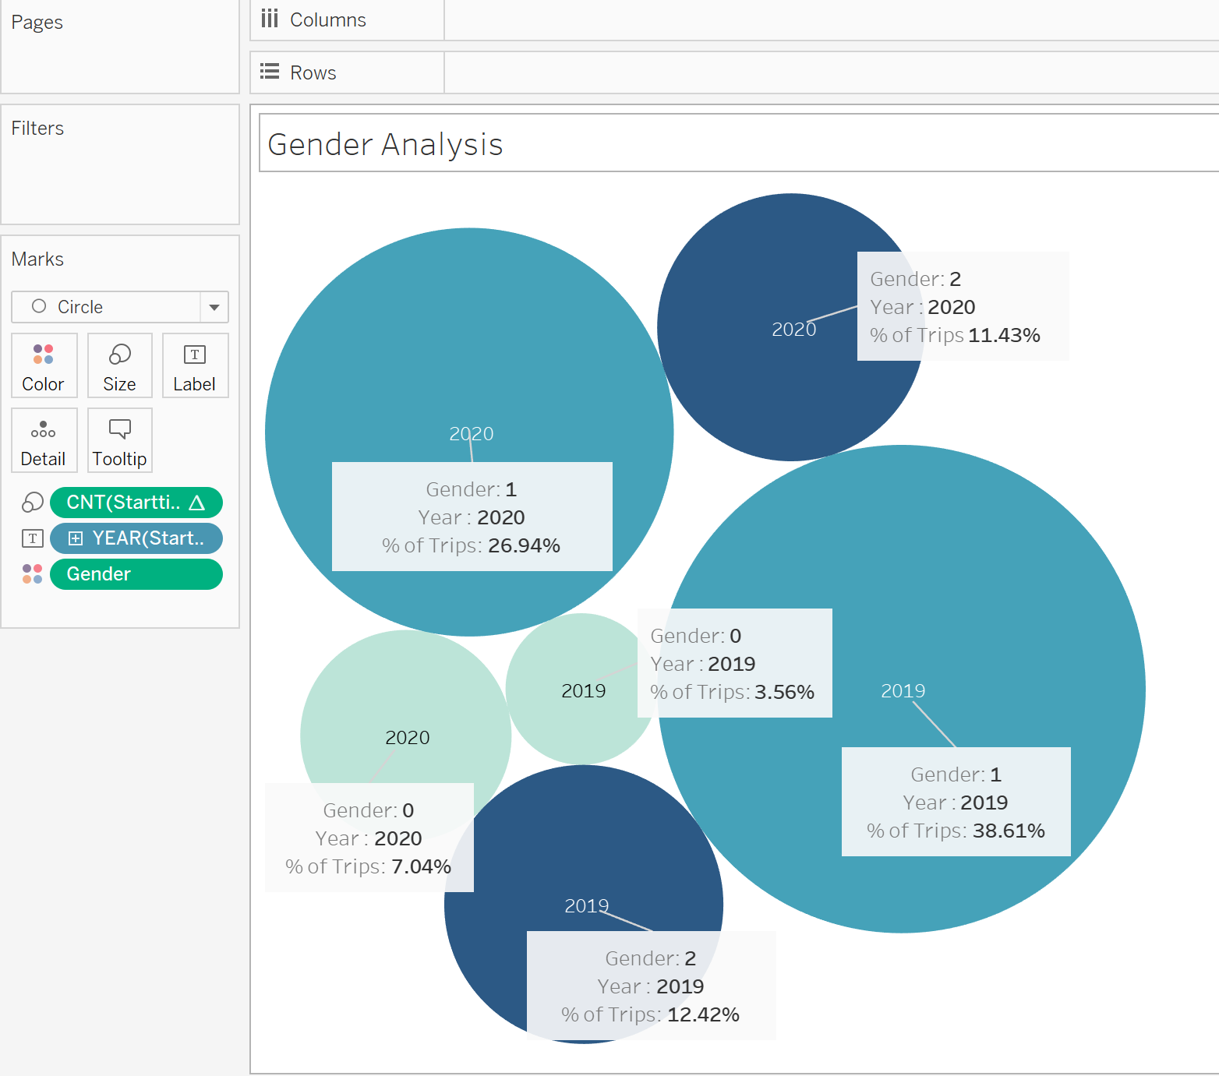

Not sure why there are three types of gender… Let’s assume Gender 1 is Male, Gender 2 is Female and Gender 0 is not defined.

• How effective has gender outreach been in increasing female ridership over the timespan?

Gender 2 hasn’t increased the ridership from 2019 to 2020.

• How does the average trip duration change by age?

The younger, the longer accept for Age 52 as an anomaly.

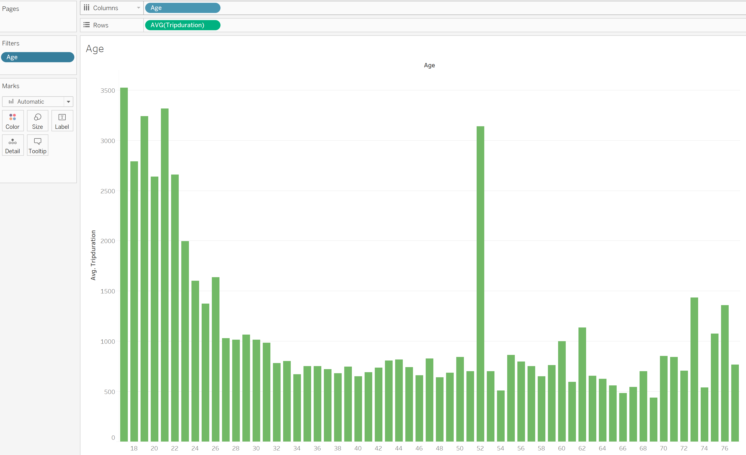

• What is the average distance in kms that a bike is ridden?

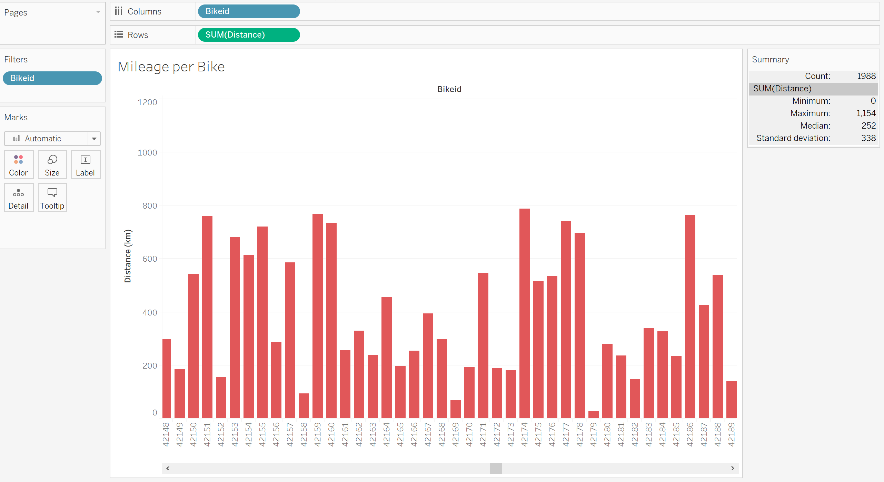

• Which bikes (by ID) are most likely due for repair or inspection in the timespan?

BikeID: 40831 & 44683 – They have really high mileage.

• How variable is the utilization by bike ID?

The standard deviation is 338.